Beyond See One, Do One:
Cognitive Apprenticeship and Motivation in Clinical Education

Core Components of Cognitive Apprenticeship
Content Dimension
- Domain Knowledge: Clinical facts, procedures, and protocols
- Strategic Knowledge: Decision-making, reasoning strategies, and metacognitive skills

Method Dimension
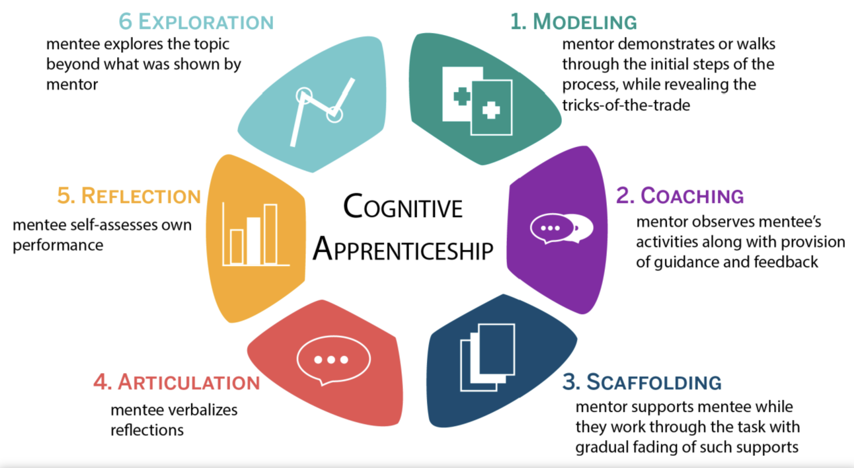
Image - https://educationaltechnology.net/cognitive-apprenticeship/

Effective Talk Moves for Cognitive Apprenticeship
- "Talk me through your reasoning as you examine this patient..."
- "What specific aspects of this case are you finding challenging?"
- "How does this compare to the case we saw yesterday?"
- "What questions do you still have about managing this condition?"
- "What would you do differently next time?"
- "Let's break this procedure down into steps..."
- "How might you apply this principle in a different clinical scenario?"
- "What additional information would help clarify your understanding?"

Remember: Cognitive apprenticeship is flexible and can be adapted to different clinical specialties, settings, and student learning needs.

Common Challenges & Evidence-Based Solutions
Challenge | Cognitive Apprenticeship Strategy | Implementation Example
Limited teaching time | Modelling + Articulation | "One-minute preceptor" technique: Ask for commitment, probe for supporting evidence, teach general rules, reinforce what was done well, correct mistakes
Student struggles with clinical reasoning | Articulation + Coaching | "Think aloud" protocol: Have students verbalise their thought process while working through a case, providing guidance at key decision points
Theory-practice gap | Scaffolding + Sociology | "Contextual linking": Connect theoretical knowledge to specific patient cases, gradually increasing complexity as student progresses
Student lacks confidence with procedures | Modelling + Coaching + Scaffolding | "Graduated supervision": Demonstrate → Assist → Observe → Provide feedback, with decreasing support over time
Students not self-directed | Reflection + Exploration | "Learning goals dialogue": Help students identify specific learning needs and create personalised learning plans with regular reflection points
Difficulty assessing clinical competence | Articulation + Reflection | "Structured case presentations": Have students present cases using a consistent framework that reveals their clinical reasoning

Boosting Motivation & Engagement for Clinical Learners

Key Motivation Frameworks

1. Increasing Motivation Level

Optimal Challenge: Tasks that are challenging but achievable

Sparking Curiosity & Interest: Creating novelty and connecting to existing interests

Modelling Enthusiasm: Authentic expression of excitement for the field

Creating Relevance: Explicitly connecting learning to greater Purpose, e.g., student's goals and future practice

2. Enhancing Motivation Quality (i.e., intrinsic vs extrinsic)

Autonomy with Structure: Providing choice within clear frameworks

Addressing Identity Contradictions: Bridging gaps between placement and career goals

Framing Challenges: Presenting difficulties as common and improvable

Eliciting Mastery Approach: Focusing on skill development over performance

3. Improving Motivation Know-How

Teaching Regulation Strategies: Sharing specific techniques for self-motivation

Modelling Motivation Regulation: Demonstrating how you manage your own motivation

Practical Talk Moves for Clinical Educators

Day 1: Building Connection & Setting the Stage

"What aspects of [specialty/site] interest you most?"

"Let me show you how this connects to your interest in [area]..."

"Many students find [task] challenging at first. I did too when I was learning."

"Here's our structure, and within that, what would you like to focus on?"

"I'm excited about [aspect of practice] because..."

Days 2+: Deepening Engagement

"Let's set specific learning goals that matter to you..."

"I notice you did [specific action] well. Next time, try..."

"When I faced similar challenges, I used this approach..."

"How could we modify this for a patient in your area of interest?"

"What questions or concerns do you have about today's cases?"

Discussion Questions for Simulation

Which motivation strategies has Dr Lyons employed effectively?
- What would you say or do next with this student? How would you tailor the placement to better motivate Sam?
- What strategy did you see that you want to employ in your placement?
- What specific talk moves could you adopt tomorrow?
- How might you adapt these approaches for:
- Different disciplines, various experience levels, challenging placement environments

