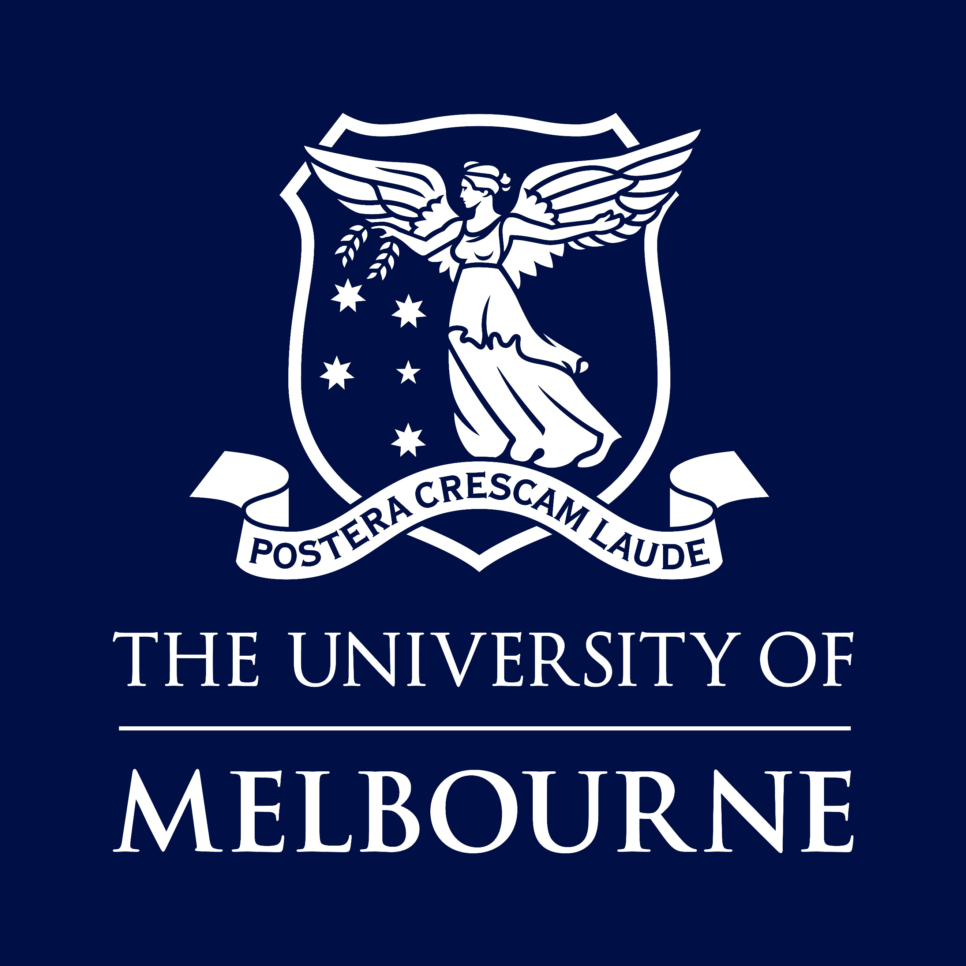

POSITION DESCRIPTION

Peeneeyt Thanampool Indigenous Postdoctoral Fellowship
Faculty of Medicine, Dentistry and Health Sciences
‘Peeneeyt Thanampool’ Indigenous Postdoctoral Fellowship
Position No
Classification | Level B Research Focussed
Salary | Level B: $124,656 - $148,023 per annum (pro rata for part-time)
Superannuation | Employer contribution of 17%
WORKING HOURS | Full time (1 FTE & 0.6 - 0.8 FTE will be considered)
BASIS OF EMPLOYMENT | Fixed term available for 3 years
Special measure | Only Indigenous Australians are eligible to apply as this position is exempt under the Special Measure Provision, Section 12 (1) of the Equal Opportunity Act 2011 (Vic)
Other Benefits | https://about.unimelb.edu.au/careers/staff-benefits
How to Apply | Online applications are preferred. Go to The Peeneeyt Thanampool (Strong Women) Aunty Joan Vickery and Aunty Angela Clarke MDHS Indigenous Post-doctoral Fellowship
contact  For enquiries only | Kristi Roberts  Email MDHS-Indigenous-postdoctoral@unimelb.edu.au  Please do not send your application to this contact
For information about working for the University of Melbourne, visit our website:
about.unimelb.edu.au/careers

Acknowledgement of Country
The University of Melbourne acknowledges the Traditional Owners of the unceded land on which we work, learn and live: the Wurundjeri Woi Wurrung and Bunurong peoples (Burnley, Fishermans Bend, Parkville, Southbank and Werribee campuses), the Yorta Yorta Nation (Dookie and Shepparton campuses), and the Dja Dja Wurrung people (Creswick campus).
The University also acknowledges and is grateful to the Traditional Owners, Elders and Knowledge Holders of all Indigenous nations and clans who have been instrumental in our reconciliation journey.
We recognise the unique place held by Aboriginal and Torres Strait Islander peoples as the original owners and custodians of the lands and waterways across the Australian continent, with histories of continuous connection dating back more than 60,000 years. We also acknowledge their enduring cultural practices of caring for Country.
We pay respect to Elders past, present and future, and acknowledge the importance of Indigenous knowledge in the Academy. As a community of researchers, teachers, professional staff and students we are privileged to work and learn every day with Indigenous colleagues and partners.

Position Summary
The Faculty of Medicine, Dentistry and Health Sciences (MDHS) Indigenous Postdoctoral Fellowship offers a career pathway for MDHS Indigenous PhD graduates (or near completion). The Fellowship aims to support the next generation of Indigenous researchers who will actively contribute to health research and/or address critical health issues facing Indigenous communities. The Fellows will contribute to and enrich the faculty’s diverse scholarly community and build an Indigenous research community that will generate Indigenous informed and led research.
The Fellows will represent our talented graduating Indigenous PhD scholars across all of the MDHS academic disciplines and will use their research as the basis for teaching during the Fellowship. Successful candidates will demonstrate a commitment to health research, research that will inform and influence practice and policy areas critical to improving Indigenous health and developing healthy futures for Indigenous communities. Fellows will receive research mentorship and support that will contribute to their participation in a global evidence-based narrative of Indigenous revitalization, development and adaptation.
The key goal of the three-year Fellowship is to develop and support the health research career of aspiring Indigenous academics. The successful candidate will be supported to achieve their proposed research goals with an experienced research mentor and advisory team relevant to the field of expertise. They will also be supported to consider an appropriate research academic trajectory which may include a Category 1 grant or equivalent.
Opportunities for national and international engagement will also be supported with a one-off stipend to cover travel and accommodation expenses. Travel plans should support professional training or development relevant to the Fellows research. Applicants are required to articulate their research plans and if successful will be in the department most relevant to their proposed research project.
Applicants are strongly encouraged to discuss their planned research projects with relevant heads of academic areas they would like to work in and their PhD supervisors (if not yet graduated).

KEY RESPONSIBILITIES
- In consultation with the assigned mentor, create a strategic research agenda that outlines appropriate research outputs for the duration of the Fellowship.
- Plan, develop and conduct research both independently and in collaboration with Departmental/Faculty staff or community-based colleagues as appropriate to the project.
- Publish peer-reviewed academic papers and other scholarly outputs.
- Present conference/symposium papers at appropriate Australian and international forums.
- Contribute to research workshops as appropriate. Where appropriate, contribute to supervision of honours or master’s higher degree students (subject to completion of PhD).
- Engage in Indigenous research activities, where appropriate
- In consultation with the assigned supervisor and using the research as the basis, contribute to teaching and learning activities, including preparation and delivery of lectures, tutorials and seminars.
- Contribute to the research team and the Department through attendance at meetings or seminars and or conferences relevant to the team’s activities and the Fellow’s research expertise.
- Contribute to the Faculty’s Indigenous Staff Network activities as appropriate
- Engage in public outreach and community engagement activities.
- Effective demonstration and promotion of University and Faculty values including diversity and inclusion and high standards of ethics and integrity
- Occupational Health and Safety (OH&S) and Environmental Health and Safety (EH&S) responsibilities as outlined in section 5.

Selection Criteria

EDUCATION/QUALIFICATIONS
- The appointee will have a PhD (awarded or near completion). Applicants must have submitted, or intend to submit, their PhD within the 2026-27 financial year.

ESSENTIAL
- UoM MDHS PhD Indigenous Australian candidates/graduate.
- A considered and well-developed research plan in line with the applicant’s developing research profile.
- Demonstrated research excellence evidenced by PhD supervisor letter, publications, conference and seminar presentations and contribution to grant applications, if any.
- Strong evidence of ability and desire to build an academic career trajectory
- Demonstrated ability to work independently and collaboratively in a team to achieve project goals and meet agreed deadlines as appropriate.
- Willingness to teach in the context of your research.

DESIRABLE
- Demonstrated capacity to work and communicate effectively in an interdisciplinary environment.

OTHER JOB-RELATED INFORMATION
- Occasional work out of ordinary hours, travel, etc.
- This position requires the incumbent hold a current and valid Working with Children Check. The University of Melbourne is dedicated to safeguarding the welfare of all community members, especially those most vulnerable. As part of our commitment to child safety and in line with the Victorian Child Safe Standards, this position will be required to hold a valid Employee WWCC, regardless of where in the University an employee may work or what work they do.
Equal Opportunity, Diversity and Inclusion
The University is an equal opportunity employer and is committed to providing a workplace free from all forms of unlawful discrimination, harassment, bullying, vilification and victimisation. The University makes decisions on employment, promotion, and reward on the basis of merit.
The University is committed to all aspects of equal opportunity, diversity and inclusion in the workplace and to providing all staff, students, contractors, honorary appointees, volunteers and visitors with a safe, respectful and rewarding environment free from all forms of unlawful discrimination, harassment, vilification and victimisation. This commitment is set out in our Diversity and Inclusion Strategy 2030 that addresses diversity and inclusion, equal employment opportunity, discrimination, sexual harassment, bullying and appropriate workplace behaviour. All staff are required to comply with all University policies.
The University values diversity because we recognise that the differences in our people’s age, race, ethnicity, culture, gender, nationality, sexual orientation, physical ability and background bring richness to our work environment. Consequently, the People Strategy sets out the strategic aim to drive diversity and inclusion across the University to create an environment where the compounding benefits of a diverse workforce are recognised as vital in our continuous desire to strive for excellence and reach our strategic targets.
Occupational Health and Safety (OHS)
All staff are required to take reasonable care for their own health and safety and that of other personnel who may be affected by their conduct. OHS responsibilities applicable to positions are published at: https://safety.unimelb.edu.au/people/community/responsibilities-of-personnel
These include general staff responsibilities and those additional responsibilities that apply for Managers and Supervisors and other Personnel.
The University of Melbourne
Established in 1853, the University of Melbourne is a leading international university with a tradition of excellence in teaching and research. The main campus in Parkville is recognised as the hub of Australia’s premier knowledge precinct comprising eight hospitals, many leading research institutes and a wide-range of knowledge-based industries. With outstanding performance in international rankings, the University is at the forefront of higher education in the Asia-Pacific region and the world.
The University of Melbourne employs people of outstanding calibre and offers a unique environment where staff are valued and rewarded.
Further information about working at The University of Melbourne is available at http://about.unimelb.edu.au/careers
Strategy 2030: Resilience
As set out in the University of Melbourne's Strategy 2030, our purpose is to benefit society through the transformative impact of our education and research. This can only be achieved by building a resilient institution, empowering our people, and working toward shared ambitions.
Our aspiration for 2030 is to be a world-leading, globally connected Australia university with students at the heart of everything we do. Strategy 2030 provides a sharp focus to advance our shared ambitions and guide us through to 2030.
It elevates three core ambitions:
- Exceptional Education: Educating our outstanding students to thrive in complexity
- Transformational Research: Creating knowledge, fostering innovation and transforming lives
- Our Resilient University: Serving and connecting Country, people and community
The strategy identifies our University’s distinctive capabilities including Indigenous scholarship, world-class curriculum, our diverse community and our global research networks and precincts.
Four focus areas for action guide decision-making and ensure the University is equipped for challenges ahead. These are: Empowering people and performance, Improving student experience, Partnering for impact and Leading with a future-focus.
For more information, visit https://about.unimelb.edu.au/strategy/strategy-2030
Other Information

MDHS INDIGENOUS DEVELOPMENT
https://mdhs.unimelb.edu.au/about/indigenous-development

Indigenous Development supports Indigenous students, staff, researchers and communities across the Faculty of Medicine, Dentistry and Health Sciences.

We work to create a strong and supportive environment for Indigenous students from their first connection with the University, through their studies and into their careers. We support Indigenous students to thrive, connect with community, develop their skills and leadership, and pursue pathways into health and research.

We work alongside Indigenous and non-Indigenous staff to strengthen Indigenous leadership, knowledge and perspectives across education, research, engagement and the health workforce.

Through partnerships across the Faculty, University and community, Indigenous Development is helping build a stronger Indigenous presence in health and create opportunities that support Indigenous success, now and into the future.

FACULTY OF MEDICINE, DENTISTRY AND HEALTH SCIENCES
https://mdhs.unimelb.edu.au/
The Faculty of Medicine, Dentistry and Health Sciences is an extremely diverse faculty comprised of six schools, and a number of departments and centres. Our Faculty is renowned for global leadership in health research, policy and practice. We recognise that partnerships and collaborations are an integral facet of our development, and a major strength of the Faculty is our ability to work collaboratively with our partners to benefit the community.
The strategic plan for the Faculty, Advancing Health 2030, outlines our vision over the coming years to be a global leader in health by driving excellence and innovation through our partnerships, producing exceptional graduates and impactful research that spans discovery to translation, and keeping students at the heart of everything we do.
Focused on three core areas, Curing Chronic Disease, Prevention and Health Equity, and Transforming Healthcare, the Faculty of Medicine, Dentistry and Health Sciences is aiming to accelerate solutions to improve healthcare in Australia and across the globe. Each Impact Area is bringing together partners from within the University of Melbourne, the Melbourne Biomedical Precinct and beyond to drive collaboration and create solutions faced by clinicians and patients alike.
We are proud to be part of a thriving, innovative ecosystem of health and biomedical organisations across Victoria. These partnerships support and amplify our impact on the health and wellbeing of our communities.
Governance
The Vice-Chancellor is the Chief Executive Officer of the University and responsible to Council for the good management of the University.
Comprehensive information about the University of Melbourne and its governance structure is available at https://about.unimelb.edu.au/strategy/governance

