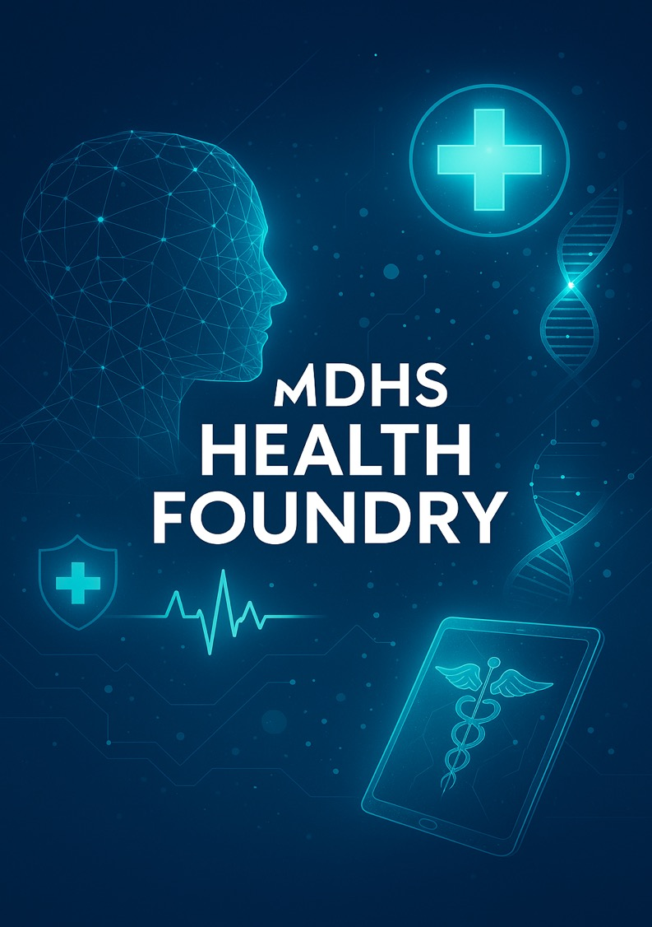

GUIDELINES

Where science meets impact – building the next
generation of health innovators

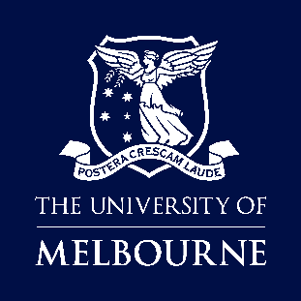

TABLE OF CONTENTS

PROGRAM OVERVIEW 3
PROGRAM STRUCTURE 3
APPLICATION PROCESS 3
KEY DATES AND LOCATIONS 4
PITCHING FORMAT 4
Preliminary Round 4
Final Round 4
PRIZE 4
TERMS AND ELIGIBILITY 4
PRIVACY COLLECTION NOTICE 5
CONTACT 6

PROGRAM OVERVIEW
The MDHS Health Foundry is an immersive, in-person program designed to introduce PhD candidates and Early Career Researchers within the Faculty of Medicine, Dentistry and Health Sciences to the fundamentals of health innovation, entrepreneurship, and impact. Tailored for those curious about commercialisation and translational research, the program offers a dynamic opportunity to connect with like-minded peers, explore the innovation ecosystem, and develop early-stage ideas and pitch skills.
Led by the MDHS Innovation and Enterprise team, participants will gain practical insights from those who have successfully turned research into real-world ventures. Through workshops, mentoring, and collaborative sessions held over two-and-a-half days, the program offers a hands-on and supportive environment — at no cost to participants — to begin their journey from researcher to innovator.
Program attendees will:
- Learn about the principles of innovation and impact including entrepreneurship and commercialisation pathways from industry start-up founders, and researchers from the Faculty of Medicine, Dentistry and Health Sciences and members of the UoM Research, Innovation and Commercialisation team.
- Interact with participants from a diverse range of disciplines from across the faculty.
- Practice presenting and communicating a health innovation project to an audience.
No prior experience is required. Participants will benefit from networking experiences, workshops and mentoring opportunities facilitated by MDHS experts, as well as feedback to help refine their project ideas.
The program culminates with teams pitching their health innovation projects to a diverse audience for a chance to win $2000 AUD.

PROGRAM STRUCTURE
- Expressions of interest via online form
- Teams are allocated in groups of up to five
- Day 1 | Launch and mixer – Participants hear from inspiring entrepreneurs and meet their teams and mentors over dinner
- Day 2 | Guest speakers’ presentations and pitch preparation workshops
- Day 3 | Continue pitch preparation and pitch final event

APPLICATION PROCESS
Applicants are invited to express their interest in participating in the program via the MDHS Health Foundry Expression of Interest online form. Selected participants must attend all three days of the event. Participants will be allocated into teams of up to five and will be notified via email before the event begins. As part of the Launch and Mixer event, all teams will gain access to mentors to refine their startup ideas.

KEY DATES AND LOCATIONS
activity | DATE & TIME | LOCATIONS
Registrations open | 9 am | 14 April 2025 | Online
Registrations close | 5 pm | 09 May 2025 | Online
Day 1 | Launch and Mixer | 5.30 pm - 8 pm | 25 May 2025 | Naughtons Hotel, Parkville
Day 2 | Guest speakers’ presentations and workshops | 9 am - 5 pm | 26 May 2025 | The Woodward Centre, Carlton
Day 3 | Pitch Preparation and Final Pitch | 9 am – 3.30 pm | 27 May 2025 | The Woodward Centre, Carlton

PITCHING FORMAT

Preliminary Round
Selected participants will be allocated into teams of up to five. During the Launch and Mixer event each member will have five minutes to pitch their research idea to their teams. Teams will choose a project idea they would like to prepare a pitch as part of the MDHS Health Foundry program.

Final Round
Teams have five minutes to present their projects to a live audience, followed by up to five minutes of comments, questions, and feedback from audience members.
The Final Round event is open to members of the University of Melbourne community. During this time, a live online vote will be held to select the winning team.

PRIZE
The winning team will be selected after the pitch presentations by the audience via online voting. The winning team will receive $2,000 cash to be split equally among team members as well as award certificates.
All other participants will receive a certificate of participation.

TERMS AND ELIGIBILITY
- The MDHS Health Foundry is open to Early Career Researchers (<5 years post award of PhD) and currently enrolled PhD from the Faculty of Medicine, Dentistry and Health Sciences.
- Places in the MDHS Health Foundry program are limited. Expression of Interest must be submitted before the cut-off date.
- Participants of the MDHS Health Foundry will be placed into teams of three to five members.
- Teams will be allocated to include members from different schools, disciplines, or skill sets by the MDHS Innovation and Enterprise directorate.
- Each participant will pitch their research idea to the group, who will then select a single project to use as the commercial ‘idea’ for the next 2 days. Teams will present a 5-minute pitch at the end of day 3 to an audience of fellow participants and invited University of Melbourne staff members. Pitch presentations will be judged by participating audience members and a $2,000 cash prize will be awarded to the first-placed pitch. This prize will be shared equally amongst the members of the winning team.
- Applicants are required to review the University of Melbourne Intellectual Property Policy (https://policy.unimelb.edu.au/MPF1320/) to ensure they understand the intellectual property arrangements for their research including any contractual specified agreements with the University and or a third party that may impact intellectual property ownership and project confidentiality.
- Applicants are required to discuss their participation in MDHS Health Foundry with their supervisor(s) prior to registering including obtaining advice regarding intellectual property arrangements and any confidentiality obligations.
- Participants and University of Melbourne staff involved in the MDHS Health Foundry including the final pitch event will not be required to sign non-disclosure statements.
- Winners of previous MDHS Health Foundry will not be eligible to re-enter the program.

PRIVACY COLLECTION NOTICE
The collection of personal information by the University of Melbourne (University) is governed by the Privacy and Data Protection Act 2014 (Vic) and Health Records Act 2001 (Vic) (together, Privacy Laws). The University is also considered to be a data controller for the purposes of the EU General Data Protection Regulation 2016/679 (GDPR) in relation to the collection of personal information from individuals located in the EU. The University is committed to protecting your privacy and processing your personal information fairly and lawfully in compliance with the Privacy Laws and the GDPR, as applicable.
The information in this form is being collected by Research Support & Evaluation, Faculty of Medicine, Dentistry and Health Sciences (MDHS), the University of Melbourne. The information you provide is being collected in order to record administrative details of the applicant for selection in the 2025 MDHS Health Foundry. The information will be used by authorised staff for the purpose for which it was collected and will be protected against unauthorised access and use.
We take all reasonable steps to ensure that the information we hold is accurate and complete and that it is protected from misuse, loss, unauthorised access or disclosure. We will only retain your personal information for as long as required for the purpose it was collected and in accordance with our legislative obligation. Your personal information will be securely stored and destroyed in accordance with the University’s retention and disposal authority. We will not disclose your personal information to anybody else unless you have given consent, or we are authorised or required to do so by law. You may request access to, or correction of, your personal information held by the University at any stage. You may exercise data subject rights under the GDPR if applicable. You can contact us at 13 63 52. For further information about how the University manages personal information, to make an enquiry or complaint, or for contact details of the University’s Privacy and Data Protection Officer, please view the University’s Privacy Policy, visit our Privacy Webpage, or contact the University’s Privacy Office at privacy-officer@unimelb.edu.au.

CONTACT
The MDHS Health Foundry program is brought to you by the Innovation & Enterprise Portfolio within the Faculty of Medicine, Dentistry and Health Sciences.

For questions about this program, please contact:

Innovation & Enterprise
E: mdhs-innovation@unimelb.edu.au
W: mdhs.unimelb.edu.au/research/innovation-and-enterprise

