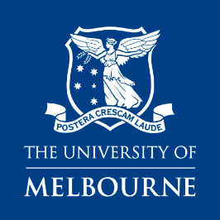

Aunty Joan Vickery Scholarship Personal Impact Form

Full name:
Email Address:
Mobile Number:
Student number
(if applicable)

Eligibility (please tick)
- The Aunty Joan Vickery Scholarship is an Identified Position in accordance with the University's Identified Position Procedure and only Aboriginal and/or Torres Strait Island descent (identity verified via the University’s Confirmation of Identity process) are eligible to apply.
- Applicants must have received an offer or be currently enrolled in a Master of Public Health degree in the Melbourne School of Population and Global Health, in the MDHS at the University of Melbourne.

- Please briefly state why you are applying for this course and motivation for studying (250 words or less)
- How will this award contribute to your future plans or aspirations? (250 words or less)

I certify that the above information is true and correct.
NAME:
SIGNATURE:
DATE:
Please contact Professor Catherine Chamberlain on cacham@unimelb.edu.au if you have any concerns or queries.
Please submit this application to MPGH Academic Programs Office to Liz Dent - e.dent@unimelb.edu.au by advertised due date.

