Stillbirth and Neonatal Deaths Research Scholarship

For graduate research students

2023 Guidelines

Opening Date: Monday 20th November 2023

Closing Date: Thursday 15th February 2024

Background
This is a Graduate Research Student scholarship to be awarded for research into stillbirth and neonatal death and disease conducted at the Royal Women’s Hospital research precinct, both for the hospital and for the University of Melbourne’s Department of Obstetrics, Gynaecology and Newborn Health (O&G), Melbourne Medical School.
As the trust was established at a time when medical interventions and risk of infant mortality and morbidity was a lot higher than it is today, research related to improving outcomes of infants at high risk; i.e., infants born pre-term, could be regarded relevant in these medically advanced times and in the spirit of the gift.
The scholarship is to be awarded from time to time, as the gift allows, to a Graduate of any University in medicine and surgery, having received an offer, or being currently enrolled, as a GR student (PhD or MPhil) conducting their research project at the Royal Women’s Hospital. The current annual amount available for award is approximately $13,255.
The scholarship is funded from an original trust deed that was established in 1937 with generous donations made to the then King’s Jubilee Fund. The funds were previously held by the City of Melbourne and the Lord Mayor before being transferred to the University of Melbourne in October 2020.

Eligibility
To be considered for this award, students must:
- Complete and submit the application form;
- Be an Australian citizen, permanent resident or international student with a relevant Australian visa;
- Have completed a degree in medicine and surgery or equivalent deemed valid by the Medical Board of Australia;
- Have received an offer, or be currently enrolled, as a Graduate Research student (PhD or MPhil) in connection with a University Medical School, hospital or similar establishment or institution.
- Be enrolled on a full-time or part-time basis;
- Be conducting their research project at the Royal Women’s Hospital.
The scholarship may be awarded a maximum of two times to the same applicant at the discretion of the selection committee.

Assessment Criteria

Applications will be judged by the Selection Panel based on the following criteria:

• Alignment of the research project with the purpose of the award (50% weighting)

• Feasibility of the project to achieving the aims and/or translation to clinical practice (25% weighting)

• Track record (CV, previous prizes, awards, grants, publications etc) (25% weighting)

Scholarship Award
- The winning applicant will be provided with a scholarship for the duration of 1 year (Per annum stipend rate: Approximately $13,255) will be paid to the awardee in a fortnightly stipend.
Conditions of Award
- To apply for this scholarship award, you need to submit your application to Janine Sala at jsala@unimelb.edu.au by the closing date and time
- Applicants with a foreign medical degree must be deemed valid by the Medical Board of Australia and applicant should verify they are a registered medical practitioner in Australia.

Key Dates
- Date for opening of applications: Monday 20th November 2023
- Final due date for submission of applications: 5.00pm Thursday 15th February 2024
- Expected date for announcement of scholarship outcome: March 2024

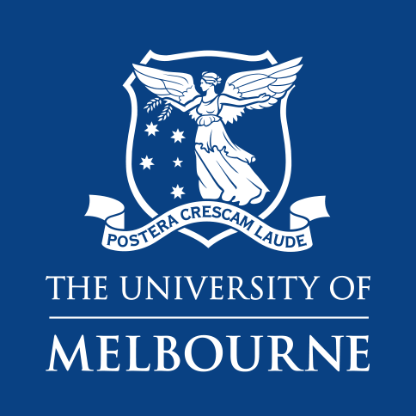

Stillbirth and Neonatal Deaths Research Scholarship

2023 Application Form

Closing Date: Closes 5.00pm Thursday 15th February 2024

IMPORTANT
Submit the signed application as a single high-quality PDF to Janine Sala at jsala@unimelb.edu.au by the closing date and time, do not include Scholarship Guidelines.

Applicant Details
Name: | Click or tap here to enter text.
Email: | Click or tap here to enter text.
Phone: | Click or tap here to enter text.
Study Level: | Choose an item.
Year of Completion: | Click or tap here to enter text.

Project Details
Title of Project: | Click or tap here to enter text.
Summary of Project: | Click or tap here to enter text.
How does the project align with Stillbirth and Neonatal Deaths Research/improving outcomes of infants at high risk: | Click or tap here to enter text.
Explain the feasibility of the project to achieving the aims and/or translation to clinical practice: | Click or tap here to enter text.

Track Record

Publications during Candidature

Grants/Awards/Prizes received during Candidature

Presentations given during Candidature

Certification by the Applicant
I certify that all details given in this application are correct, and that if successful, I will hold the Stillbirth and Neonatal Deaths Research Scholarship in accordance with the scheme guidelines.
Signature: | Date:  Click or tap to enter a date.

Certification by the Supervisor
I certify that all details given in this application are correct, and the nominee meets the eligibility criteria outlined in this document.
Name:
Click or tap here to enter text.
Signature: | Date:  Click or tap to enter a date.

